**Asg 4 Debugging log**

**Version control document:** [**https://github.com/FPStruck/A4-MF/commits/main**](https://github.com/FPStruck/A4-MF/commits/main)

Bug 1

Point of Failure: Potential error at line 226 in Library.java, Variable currentLoan.discharge(isDamaged) is incorrect. Removed line.

H0: currentLoan.discharge(isDamaged) is reported incorrectly

T0: Variable may return the item is damaged even if it isn’t. Variable will be removed and program will be tested for results.

Result0: H0 false: the variable is reported correctly, other methods may be interrupting correct output a potential file that should be investigated should be the patron file, further errors occurred during running of program from H0. Item 3 is constantly in loan state and cannot be borrowed. Library file is not the source of infected code. Restoring Library.java file to original state.

Point of Failure: Potential error at line 82 and 102 in Patron.java, Variable finesOwing += loan.getFines() and finesOwing += fines may be incorrect. Modified line 102 to finesOwing += fines – finesOwing and line 82 to finesOwing = finesOwing + loan.getFines().

H1: owed fines are reported incorrectly, the result of modification should present correct results based on a series of tests for both damaged and undamaged items with total fines obtained.

**Before**

**After**

T1: Inspection of both line 82 and line 102 variables will be inspected and tested

Result1: H1 true: Variable 82 and 102 play a role in the bug. They both were infected but the incorrect result has been output. Further modification to these variables required.

Point of Failure: Modification of line 102 and 82 in the patron file should result in a correct output

H2: Refinement to fines owed calculations in patron file should result in correct output. Modifications to line 102 were made from finesOwing += fine – finesOwing to finesOwing += fine – 2. Line 82 will stay the same to investigate if line 102 was the issue

**Before**

**After**

T2: Modifications to line 102 will be tested for correct output. Testing one normal item and one damaged item for correct output result. Then for the final test I will test both normal and damaged together.

**Normal Item (undamaged) pay fine test:**

**Damaged item pay fine test:**

**Damaged item and normal item (undamaged) pay fine test:**

Result2: H1 true: Variable 82 and 102 play a role in the bug. Both variables were infected and resulted in incorrect outputs. The modification of these variables eliminated the bug and correct results were obtained.

Upon testing for two damaged items to confirm the bug is eliminated. This is the pay fine use case ui result

Bug 2

Point of Failure: Potential error at line 21 in Library.java, Variable LOAN_LIMIT = 2; is incorrect. Modified line to = 1.

H0: Because the user is able to borrow more than one item and the loan limit error is displayed after the third item, I suspect that the error takes into account the number 0 as a part of the loan limit. I have reduced the loan limit to 1 to determine if this is the case and if this prevents the user from borrowing again in separate sessions. Current code displayed below

T0: Variable may increase the loan limit allowed by the user, variable will be tested for any resolutions to the bug or any effect on it. Modified code and testing below

Result0: H0 false: The variable has an effect on the loan limit of the first session but does not resolve the bug. User can still borrow again in the second session. I believe that investigation into the borrow item control use case would provide helpful. Code has been reverted back to original state

Point of Failure: Potential error at line 79 in BorrowItemControl.java, Variable library.getNumberOfLoansRemaingForPatron(patron) – pendingList.size() < 0 may be the cause of the bug.

H1: In my opinion if the variable was changed from 0 to 1, the bug would be eliminated from the program as the program takes into account the 0 variable and assigns three loans instead of two. The use of the variable 1 as a replacement should reduce the number of loans allowed. Current code below

T1: This test will determine if the changes made to the code will result in any resolutions to the bug and eliminate it from the program. Below is the changes made to the code and the tests

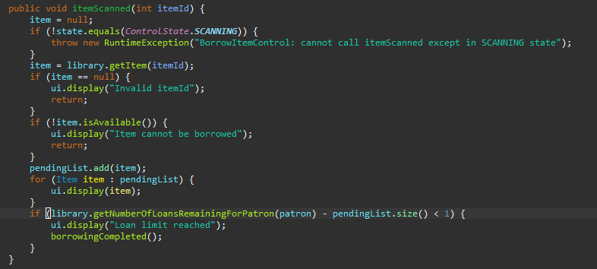

**First session of borrowing**

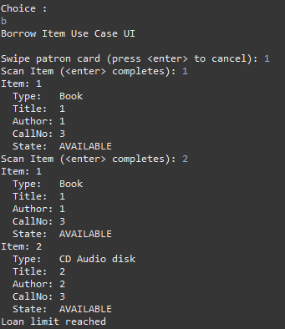

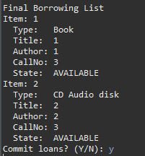

**Second session of borrowing**

R1: H1 true: The patron can no longer borrow more than two items in both the same and multiple sessions. The bug has been successfully resolved